Program Screenshot
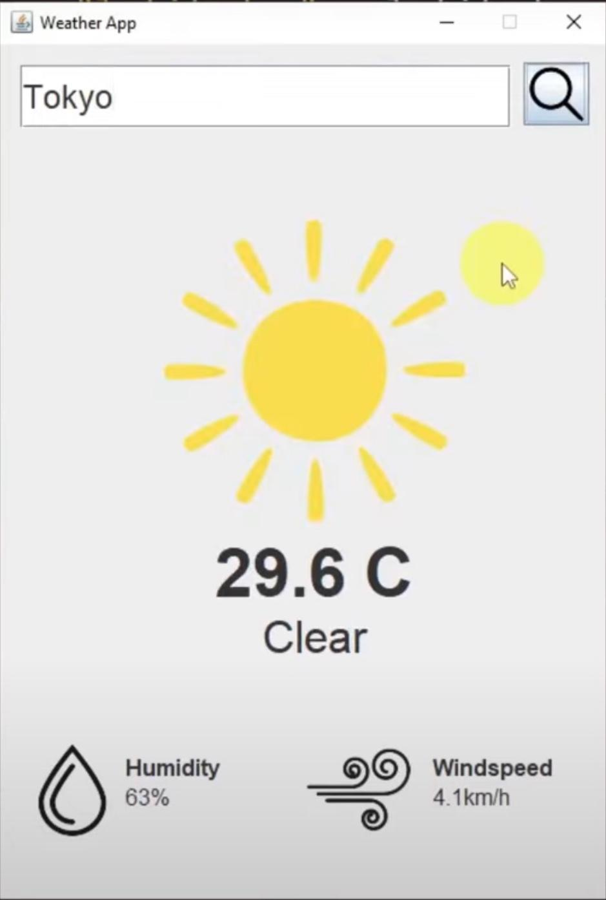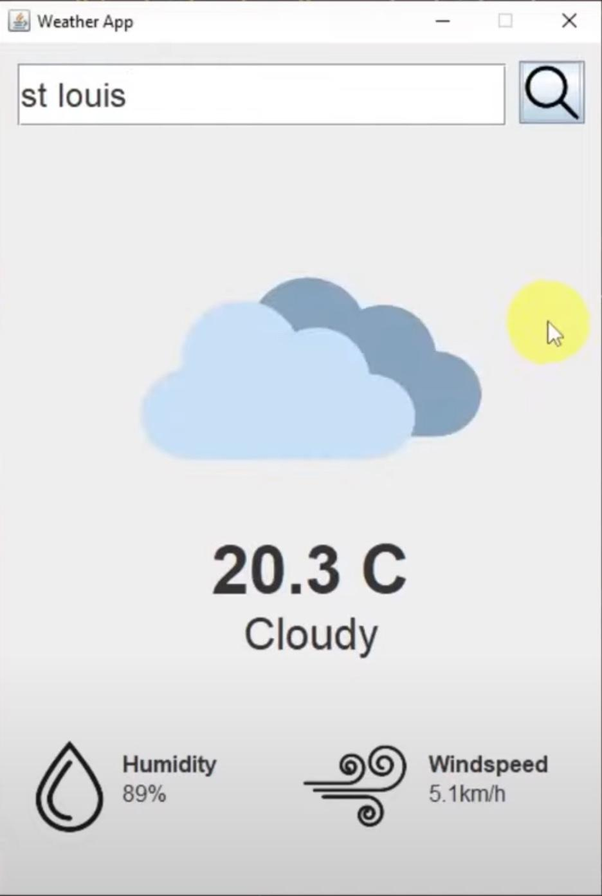

Program Code

AppLauncher.java
import javax.swing.*;
public class AppLauncher {
public static void main(String[] args) {
SwingUtilities.invokeLater(new Runnable(){
@Override
public void run(){
new WeatherAppGui().setVisible(true);
}
});
}
}

WeatherApp.java
import org.json.simple.JSONArray;
import org.json.simple.JSONObject;
import org.json.simple.parser.JSONParser;

import java.io.IOException;
import java.net.HttpURLConnection;
import java.net.URL;
import java.time.LocalDateTime;
import java.time.format.DateTimeFormatter;
import java.util.Scanner;

// retreive weather data from API - this backend logic will fetch the latest weather
// data from the external API and return it. The GUI will
// display this data to the user
public class WeatherApp {
// fetch weather data for given location
public static JSONObject getWeatherData(String locationName){
// get location coordinates using the geolocation API
JSONArray locationData = getLocationData(locationName);

// extract latitude and longitude data
JSONObject location = (JSONObject) locationData.get(0);
double latitude = (double) location.get("latitude");
double longitude = (double) location.get("longitude");

// build API request URL with location coordinates
String urlString = "https://api.open-meteo.com/v1/forecast?" +
"latitude=" + latitude + "&longitude=" + longitude +
"&hourly=temperature_2m,relativehumidity_2m,weathercode,windspeed_10m&timezone=America%2FLos_Angeles";

try{
// call api and get response
HttpURLConnection conn = fetchApiResponse(urlString);

// check for response status
// 200 - means that the connection was a success
if(conn.getResponseCode() != 200){
System.out.println("Error: Could not connect to API");
return null;
}

// store resulting json data
StringBuilder resultJson = new StringBuilder();
Scanner scanner = new Scanner(conn.getInputStream());
while(scanner.hasNext()){
// read and store into the string builder
resultJson.append(scanner.nextLine());
}

// close scanner
scanner.close();

// close url connection
conn.disconnect();

// parse through our data
JSONParser parser = new JSONParser();
JSONObject resultJsonObj = (JSONObject) parser.parse(String.valueOf(resultJson));

// retrieve hourly data
JSONObject hourly = (JSONObject) resultJsonObj.get("hourly");

// we want to get the current hour's data
// so we need to get the index of our current hour
JSONArray time = (JSONArray) hourly.get("time");
int index = findIndexOfCurrentTime(time);

// get temperature
JSONArray temperatureData = (JSONArray) hourly.get("temperature_2m");
double temperature = (double) temperatureData.get(index);

// get weather code
JSONArray weathercode = (JSONArray) hourly.get("weathercode");
String weatherCondition = convertWeatherCode((long) weathercode.get(index));

// get humidity
JSONArray relativeHumidity = (JSONArray) hourly.get("relativehumidity_2m");
long humidity = (long) relativeHumidity.get(index);

// get windspeed
JSONArray windspeedData = (JSONArray) hourly.get("windspeed_10m");
double windspeed = (double) windspeedData.get(index);

// build the weather json data object that we are going to access in our frontend
JSONObject weatherData = new JSONObject();
weatherData.put("temperature", temperature);
weatherData.put("weather_condition", weatherCondition);
weatherData.put("humidity", humidity);
weatherData.put("windspeed", windspeed);

return weatherData;
}catch(Exception e){
e.printStackTrace();
}

return null;
}

// retrieves geographic coordinates for given location name
public static JSONArray getLocationData(String locationName){
// replace any whitespace in location name to + to adhere to API's request format
locationName = locationName.replaceAll(" ", "+");

// build API url with location parameter
String urlString = "https://geocoding-api.open-meteo.com/v1/search?name=" +
locationName + "&count=10&language=en&format=json";

try{
// call api and get a response
HttpURLConnection conn = fetchApiResponse(urlString);

// check response status
// 200 means successful connection
if(conn.getResponseCode() != 200){
System.out.println("Error: Could not connect to API");
return null;
}else{
// store the API results
StringBuilder resultJson = new StringBuilder();
Scanner scanner = new Scanner(conn.getInputStream());

// read and store the resulting json data into our string builder
while(scanner.hasNext()){
resultJson.append(scanner.nextLine());
}

// close scanner
scanner.close();

// close url connection
conn.disconnect();

// parse the JSON string into a JSON obj
JSONParser parser = new JSONParser();
JSONObject resultsJsonObj = (JSONObject) parser.parse(String.valueOf(resultJson));

// get the list of location data the API gtenerated from the lcoation name
JSONArray locationData = (JSONArray) resultsJsonObj.get("results");
return locationData;
}

}catch(Exception e){
e.printStackTrace();
}

// couldn't find location
return null;
}

private static HttpURLConnection fetchApiResponse(String urlString){
try{
// attempt to create connection
URL url = new URL(urlString);
HttpURLConnection conn = (HttpURLConnection) url.openConnection();

// set request method to get
conn.setRequestMethod("GET");

// connect to our API
conn.connect();
return conn;
}catch(IOException e){
e.printStackTrace();
}

// could not make connection
return null;
}

private static int findIndexOfCurrentTime(JSONArray timeList){
String currentTime = getCurrentTime();

// iterate through the time list and see which one matches our current time
for(int i = 0; i < timeList.size(); i++){
String time = (String) timeList.get(i);
if(time.equalsIgnoreCase(currentTime)){
// return the index
return i;
}
}

return 0;
}

private static String getCurrentTime(){
// get current date and time
LocalDateTime currentDateTime = LocalDateTime.now();

// format date to be 2023-09-02T00:00 (this is how is is read in the API)
DateTimeFormatter formatter = DateTimeFormatter.ofPattern("yyyy-MM-dd'T'HH':00'");

// format and print the current date and time
String formattedDateTime = currentDateTime.format(formatter);

return formattedDateTime;
}

// convert the weather code to something more readable
private static String convertWeatherCode(long weathercode){
String weatherCondition = "";
if(weathercode == 0L){
// clear
weatherCondition = "Clear";
}else if(weathercode > 0L && weathercode <= 3L){
// cloudy
weatherCondition = "Cloudy";
}else if((weathercode >= 51L && weathercode <= 67L)
|| (weathercode >= 80L && weathercode <= 99L)){
// rain
weatherCondition = "Rain";
}else if(weathercode >= 71L && weathercode <= 77L){
// snow
weatherCondition = "Snow";
}

return weatherCondition;
}
}

WeatherAppGui.java
import org.json.simple.JSONObject;

import javax.imageio.ImageIO;
import javax.swing.*;
import java.awt.*;
import java.awt.event.ActionEvent;
import java.awt.event.ActionListener;
import java.awt.image.BufferedImage;
import java.io.File;
import java.io.IOException;

public class WeatherAppGui extends JFrame {
private JSONObject weatherData;

public WeatherAppGui(){
// setup our gui and add a title
super("Weather App");

// configure gui to end the program's process once it has been closed
setDefaultCloseOperation(EXIT_ON_CLOSE);

// set the size of our gui (in pixels)
setSize(450, 650);

// load our gui at the center of the screen
setLocationRelativeTo(null);

// make our layout manager null to manually position our components within the gui
setLayout(null);

// prevent any resize of our gui
setResizable(false);

addGuiComponents();
}

private void addGuiComponents(){
// search field
JTextField searchTextField = new JTextField();

// set the location and size of our component
searchTextField.setBounds(15, 15, 351, 45);

// change the font style and size
searchTextField.setFont(new Font("Dialog", Font.PLAIN, 24));

add(searchTextField);

// weather image
JLabel weatherConditionImage = new JLabel(loadImage("src/assets/cloudy.png"));
weatherConditionImage.setBounds(0, 125, 450, 217);
add(weatherConditionImage);

// temperature text
JLabel temperatureText = new JLabel("10 C");
temperatureText.setBounds(0, 350, 450, 54);
temperatureText.setFont(new Font("Dialog", Font.BOLD, 48));

// center the text
temperatureText.setHorizontalAlignment(SwingConstants.CENTER);
add(temperatureText);

// weather condition description
JLabel weatherConditionDesc = new JLabel("Cloudy");
weatherConditionDesc.setBounds(0, 405, 450, 36);
weatherConditionDesc.setFont(new Font("Dialog", Font.PLAIN, 32));
weatherConditionDesc.setHorizontalAlignment(SwingConstants.CENTER);
add(weatherConditionDesc);

// humidity image
JLabel humidityImage = new JLabel(loadImage("src/assets/humidity.png"));
humidityImage.setBounds(15, 500, 74, 66);
add(humidityImage);

// humidity text
JLabel humidityText = new JLabel("<html><b>Humidity</b> 100%</html>");
humidityText.setBounds(90, 500, 85, 55);
humidityText.setFont(new Font("Dialog", Font.PLAIN, 16));
add(humidityText);

// windspeed image
JLabel windspeedImage = new JLabel(loadImage("src/assets/windspeed.png"));
windspeedImage.setBounds(220, 500, 74, 66);
add(windspeedImage);

// windspeed text
JLabel windspeedText = new JLabel("<html><b>Windspeed</b> 15km/h</html>");
windspeedText.setBounds(310, 500, 85, 55);
windspeedText.setFont(new Font("Dialog", Font.PLAIN, 16));
add(windspeedText);

// search button
JButton searchButton = new JButton(loadImage("src/assets/search.png"));

// change the cursor to a hand cursor when hovering over this button
searchButton.setCursor(Cursor.getPredefinedCursor(Cursor.HAND_CURSOR));
searchButton.setBounds(375, 13, 47, 45);
searchButton.addActionListener(new ActionListener() {
@Override
public void actionPerformed(ActionEvent e) {
// get location from user
String userInput = searchTextField.getText();

// validate input - remove whitespace to ensure non-empty text
if(userInput.replaceAll("\\s", "").length() <= 0){
return;
}

// retrieve weather data
weatherData = WeatherApp.getWeatherData(userInput);

// update gui

// update weather image
String weatherCondition = (String) weatherData.get("weather_condition");

// depending on the condition, we will update the weather image that corresponds with the condition
switch(weatherCondition){
case "Clear":
weatherConditionImage.setIcon(loadImage("src/assets/clear.png"));
break;
case "Cloudy":
weatherConditionImage.setIcon(loadImage("src/assets/cloudy.png"));
break;
case "Rain":
weatherConditionImage.setIcon(loadImage("src/assets/rain.png"));
break;
case "Snow":
weatherConditionImage.setIcon(loadImage("src/assets/snow.pngImage"));
break;
}

// update temperature text
double temperature = (double) weatherData.get("temperature");
temperatureText.setText(temperature + " C");

// update weather condition text
weatherConditionDesc.setText(weatherCondition);

// update humidity text
long humidity = (long) weatherData.get("humidity");
humidityText.setText("<html><b>Humidity</b> " + humidity + "%</html>");

// update windspeed text
double windspeed = (double) weatherData.get("windspeed");
windspeedText.setText("<html><b>Windspeed</b> " + windspeed + "km/h</html>");
}
});
add(searchButton);
}

// used to create images in our gui components
private ImageIcon loadImage(String resourcePath){
try{
// read the image file from the path given
BufferedImage image = ImageIO.read(new File(resourcePath));

// returns an image icon so that our component can render it
return new ImageIcon(image);
}catch(IOException e){
e.printStackTrace();
}

System.out.println("Could not find resource");
return null;
}
}

Program Documentation
The Weather App is a Java-based application that provides users with real-time weather information for a specified location. It fetches weather data from an external API and displays it in a graphical user interface (GUI). Users can enter a location, and the app retrieves and presents weather details, including temperature, weather condition, humidity, and wind speed. This documentation outlines the project's architecture, technologies used, and the functionality of each class within the application.

Technology used
The Weather App utilizes the following technologies and libraries:

- Java 18
- JSON Simple - Used to parse and read through JSON data
- HTTPURLConnection - Java's built-in library for making HTTP requests to fetch data from external APIs.

File Summaries

AppLauncher.java
This file serves as the entry point for the Weather App. It initializes the GUI and displays the main application window.

WeatherAppGui.java
This file represents the graphical user interface (GUI) of the Weather App. It is responsible for displaying weather information for a specified location.

It also handles the layout and display of GUI components, including text fields, labels, buttons, and images. It also implements the user interface for entering a location and updating the weather information based on user input.

WeatherApp.java
The file contains the backend logic for fetching weather data from an external API. It retrieves geographic coordinates for a location, fetches weather data for that location, and provides methods to convert weather codes.

It encapsulates the core functionality of the Weather App. It includes methods to fetch weather data and location coordinates, convert weather codes into readable weather conditions, and manage API requests. It also acts as the bridge between the GUI and the external weather data source, ensuring that weather information is retrieved and displayed accurately.

